Raspberry Pi Weather Station

Project Team Members
Anna Weeks
Landon Rawson
Chris Given

Project Summary
Our project will be similar to a weather station. One Raspberry Pi will be placed outside with sensors to detect humidity, temperature, and other weather values. It will then display these values through another Pi conveniently located inside.

Goals and Objectives
This project’s main goal is to make life easier for its user by eliminating the need to check the weather for the day. Instead of having to pull up an app or watch the weather channel, important information about the day’s weather will already be displayed nicely on the Pi screen. This project also may be more accurate than checking the weather channel, as the values calculated can be taken from right outside the user’s window.

Github Repository
This project's Github repository is located at: https://github.com/cgiven25/Final-RPi-Project

Bill of Materials
Itemize the required physical/electronic/hardware components (e.g., Raspberry Pi B v3, HC-SR04 ultrasonic ranging module, 5mm red diffused LEDs, etc), software components (e.g., Python v2.7.9, etc), and any other components that are relevant to your project.

GPIO and GUI
This project will use unique sensors to detect temperature, humidity etc. These sensors will be connected to the breadboard of the Pi placed outside. The sensors will send data to the Pi as input through the GPIO inputs. One of the most important aspects of this project is that the weather information calculated is displayed nicely and is easy to read. The data calculated by the first Pi will be sent to a webpage and formatted in HTML. The Pi displaying the information, located inside, will have this webpage pulled up full screen.
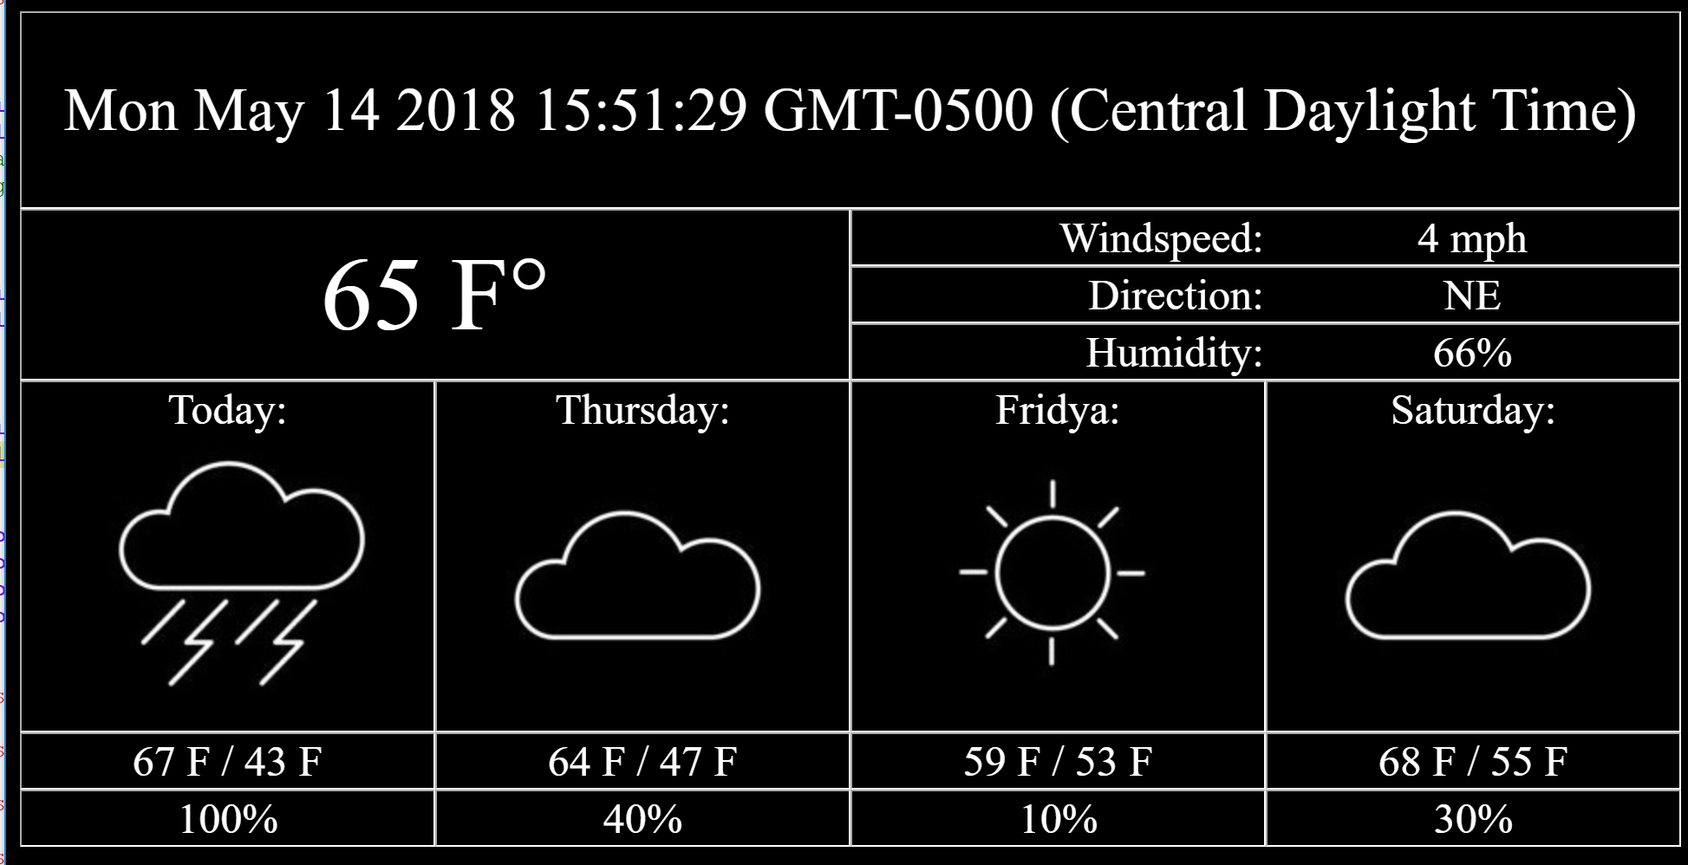

Gantt Chart

Future Development Plans
If you were to continue working on this project, what would you do? Where could you go from here to make it better? What could be done to make it have increased broader impact?

Lessons Learned
What did you learn by working on the project throughout the course? How did it relate to the Living with Cyber curriculum? How was the experience beneficial to problem solving in general? What did you learn that will benefit you in future courses in the curriculum?

